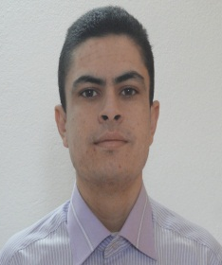
Engineering Electromechanical
HADRICH Ayman

293 street Moktar Ezziadi Sakit Ezzit Phone: 0021695670600
Sfax Tunisie Mail : ayman26hadrich@gmail.com
Borne in 26 July 1989 Driving license B
Study
2010-2013: National School Engineering of Sfax : ENIS.
Engineering Electromechanical.
First years (13.15 of average), second years (11.85 of average), third years (14.47 of average).
2008-2010: Preparing School for Engineering of Sfax.
First years (12.24 of average), second years (9.88 of average + diplomate).
2004-2008: Monji slim School of Sfax.
BAC Mathematic (16.33of average).
Professionnal Experience
• 2013, 5 months: Engineering Stage
FEMTO-ST Mechanical department of laboratory of Besancon (French)
Final study project of research on the nonlinear dynamics entitled Modeling of dynamic compartment of granular particle.
• 2012, 1 month: Maintenance Stage.
OXYGENE aeronautical: design and realization of opening / closing cab of Sport Cover.
• 2012, 1 month: Maintenance Stage.
AFROFLEX composite: works with maintenance group.
• 2011,1 month: Maintenance Stage.
SNCFT: works with maintenance group.
Competence
Software: - Office: Word, Excel, Power point
- Programming: Turbo pascal, Matlab, Maple.
- CAO, DAO, FAO, CSAO: AutoCAD, Solid works, Catia, Mastercam, Cosmos, Abaqus

Languages: - Arabic: very good.
- French: good level.
-English : good level.
Interests: - Music
- Travel
- Volleyball and foot
- Marine fishing

