First Name : Mohamed Amine  Last Name : BEN SOUF  Occupation : Associate professor  Speciality : Mechanical engineering  Affiliation : National Engineering School of Monastir  Phone : +216 23 93 50 72  Fax :  e-mail :bensouf.mohamedamine@gmail.com  Postal Adress : BP N° 22 Sfax 3000 Tunisia | 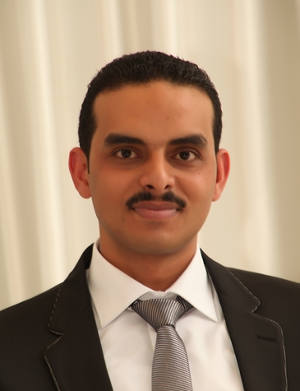
Professional Experience :
2013-2014: Associate professor in National Engineering School of Monastir

Research Activities :
- Postdoctoral in mechanical engineering , Ecole Centrale Lyon
- PhD Student in mechanical engineering , Ecole Centrale Lyon and National Engineering
School of Sfax
- Engineer diploma in mechanical engineering , National Engineering School of Sfax
Journal Papers :
[A1] M. N. Ichchou, F. Bouchoucha, M. A. Ben Souf, O. Dessombz and M. Haddar. ’Stochastic
wave finite element for random periodic media through first-order perturbation’, Computer
Methods in Applied Mechanics and Engineering, 200(41-44) :2805 – 2813, 2011.
[A2] M. A. Ben Souf, O. Bareille, M. N. Ichchou, B. Troclet, and M.Haddar. ’Variability of
coupling loss factors through a wave finite element technique’, Journal of sound and
vibration, 332 (2013) 2179–2190.
[A3] M. A. Ben Souf, O. Bareille, M. N. Ichchou, and M. Haddar. ’On the dynamics of uncertain coupled structures through a wave based method in mid- and high-frequency ranges’, Computational Mechanics, 52, Issue 4, 849-860, 2013
[A4] M. A. Ben Souf, O. Bareille, M. N. Ichchou, F. Bouchoucha, and M. Haddar. ’Wave and energy in random elastic guided media through stochastic wave finite element’, Physics letters A, 377, Issue 37, 2255-2264, 2013

Conference Papers :
[C1] M. A. Ben Souf, M. N. Ichchou, O. Bareille and M. Haddar. ’Forced response of uncertain
waveguide through the wave finite element technique’, ISMA2012, 17 - 19 Septembre,
2012, Louvain, Belgique.
[C2] M. A. Ben Souf, M. N. Ichchou, O. Bareille and M. Haddar. ’Variability of dynamic
behavior of finite coupled structure with uncertainties’, CSNDD2012, 30 Avril - 2 Mai,
2012, Marrakech, Maroc.
[C3] M. A. Ben Souf, M. N. Ichchou, O. Bareille and M. Haddar. ’Effect of uncertainties in
default detection through the wave finite elements’, CMMNO2012, 26 - 28 Mars, 2012,
Hammamet, Tunisie.
[C4] M. A. Ben Souf, M. N. Ichchou, F. Bouchoucha, O. Bareille and M. Haddar. ’Approche
énergétique pour des guides d’ondes stochastiques : formulation et validation’, CFM2011,
28 Aout - 2 Septembre 2011, Besançon, France.
[C5] M. A. Ben Souf, F. Bouchoucha, M. N. Ichchou, O. Bareille and M. Haddar. ’Stochastic
Wave Finite Element : Formulations, Validation and Generalisation’, ISMA2010, 20 - 22
Septembre 2010, Louvain, Belgique.
[C6] M. A. Ben Souf, M. N. Ichchou,O. Bareille and M. Haddar. ’Stochastic Wave Finite
Element’, IMPACT2010, 22 - 24 Mars 2010, Djerba, Tunisie.
[C7] M. A. Ben Souf, O. Bareille, M. N. Ichchou, N. Bouhaddi and M. Haddar. ’Dynamics of
stochastic and periodic structures in mid-frequency range’, Medyna2013, 23 - 25 Avril,
2013, Marrakech, Maroc.
[C8] M. A. Ben Souf, O. Bareille, M. N. Ichchou and M. Haddar. ’Variability of Energetic
diffusion coefficients through a wave finite element technique’, CMSM2013, 25 - 27 Mars,
2013, Djerba, Tunisie.

