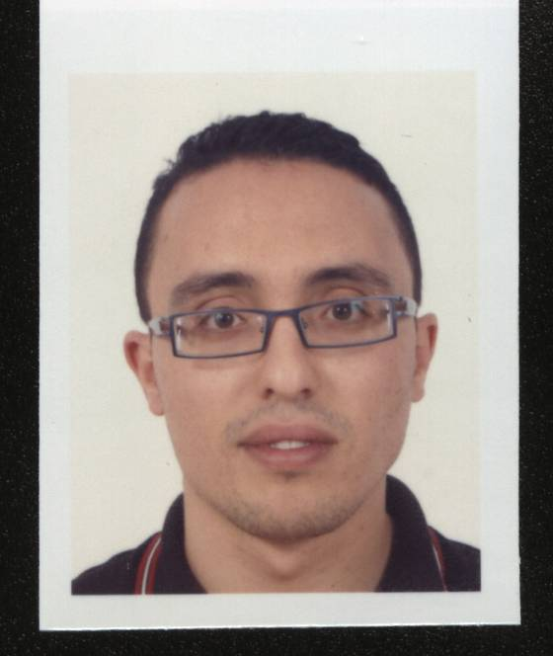
ABID MAJDI
ELECTROMECHANICAL ENGINEER
Mailing address :
Mahdia Road Km 7 SakietEddayer 3011 SFAX
E-mail : majdiab@yahoo.fr
Phone : 24 85 35 58
Date and Place of Birth : 15 May 1982 TUNIS

Family situation : Maried

Qualifications
2013 : Ph.D. in Mechanical «Monitoring and diagnosis of fans with acoustic method»
Laboratory of Mechanics, Modelling and Manufacturing
(LA2MP) National School of Engineers of Sfax (ENIS - Tunisia)

2008 : Master's degree in Mechanical and Engineering (option: Dynamic)
«Study and optimization of sound insulation walls including multilayered viscoelastic materials »
Laboratory of Mechanics, Modelling and Manufacturing
(LA2MP) National School of Engineers of Sfax (ENIS - Tunisia) and Roberval Laboratory, University of Technology of Compiègne (Roberval, UTC France)

2006 : Engineering Degree: Electromechanical Engineering
« Study, design and automation of a chroming line »
Mechanical Department at the National School of Engineers of Sfax

2003 : National Competition for admission to graduate engineering studies
Preparatory Institute for Engineering Studies of Tunis

2001 : Mathematical Baccalaureate
High School 9 April Sidi Bouzid

Professional courses

2005 : Technician training
A Month in the company TPA : electricity and auto mechanics.

2004 : Worker training
A Month in the company SIDILEC: study of electrical harnesses

12/2006 Function: Site Engineer
7/2007 Support for 8 months to complete assembly of an oil refinery olive removed from Italy and settled in society CHO Company (road Mahdia Sfax).

Educational activities

20112014 Assistant at the preparatory institute for engineering studies of GAFSA
Lesson General Mechanic: 1st and 2nd level preparatory year.
(Scientific formation)
2010-2011 Contractual assistant at the National School of Engineers of Sfax, Départementde Mechanical Engineering (3rd contract)
2nd year Engineering Electromechanical Engineer Formation:
Power transmission
1st year Engineering Electromechanical Engineer Formation:
Upgrade mechanical conception.
2009-2010 Contractual assistant at the National School of Engineers of Sfax, Départementde Mechanical Engineering (2nd contract)
2nd year Engineering Electromechanical Engineer Formation:
Mechanical conception.
1st year Engineering Electromechanical Engineer Formation:
Upgrade mechanical conception.
2008-2009 Contractual assistant at the National School of Engineers of Sfax, Départementde Mechanical Engineering (1st contract)
1st year Engineering Electromechanical Engineer Formation
Mechanical conception
1st year Engineering Electromechanical Engineer Formation
Upgrade mechanical conception.
2nd year Engineering Electromechanical Engineer Formation
Mecanical vibration.

Scientific publications

Article 1: Received July 2013, Accepted March 2014
H. Trabelsi,MajdiAbid, M. Taktak, T. Fakhfeakh, M. Haddar. “Reconstruction of the unsteady rotating forces of fan’s blade from far-field sound pressure”.
AppliedAcoustics 2014

Article 2: Received August 2010, Accepted February 2012
MajdiAbid, M. S. Abbes, J. D. Chazot, L. Hammemi, M. A. Hamdi, M. Haddar. “Acoustic Response of a Multilayer Panelwith Viscoelastic Material”.
International Journal of Acoustics and Vibration, Vol. 17, No. 2, 2012

Article 3: Received September 2011, Accepted April 2012
Majdi Abid, H. Trabelsi, M. Taktak, J. Antoni, J.M. Ville, T. Fakhfeakh, M. Haddar.
“Tonal prediction of a faulty axial fan”.
Applied Acoustics,Vol. 73 , Issue 10, 2012
Article 4: Submitted 2014
H. Trabelsi; MajdiAbid; M. Taktak, T. Fakhfakh; M. Haddar
“Sensibility and uncertainty analyzes of the tonal noise modelprediction of an axial fan”.
Applied Acoustics.

Communication 1 :
M. Abid, H. Trabelsi, M. Taktak, M. Haddar.
«Acoustic reconstruction of the unsteady rotating forces of fan’s blade ».
1st Euro-Mediterranean Conference on Structural Dynamics and Vibroacoustics (MEDYNA 2013), 23 - 25 April 2013,

Communication 2 :
M. Abid, H. Trabelsi, M. Taktak, M. Haddar.
« Reconstruction des sources acoustiques dans un ventilateur axial par méthode inverse ».
5ème Congrès International Conception et Modélisation des Systèmes Mécaniques (CMSM 2013), 25– 27 Mars 2013, Djerba, Tunisie.

Communication 3 :
H. Trabelsi, M. Abid, J. Antoni, J.M. Ville, M.Taktak, T. Fakhfakh, M. Haddar«Defects Diagnosis of an Axial Fan using the Acoustic Directivity Measurement and Computation ».
2nd International Conference Condition Monitoring of Machineryin Non-Stationary Operations (CMMNO 2012) , 26 – 28 mars 2012 , Hammamet,Tunisie.

Formations
February 2012 Pedagogical formation : GAFSA
February 2013 Pedagogical formation : SFAX
February 2010 English For Academic Purposes * Listening in academic setting *
National School of Engineers of Sfax.
February 2010 English For Academic Purposes * Speaking in academic setting *
National School of Engineers of Sfax.
January 2009 English For Academic Purposes * Reading research articles *
National School of Engineers of Sfax.
January 2009 English For Academic Purposes (30h anglais pour master)
National School of Engineers of Sfax.
May 2008 Pedagogical formation
National School of Engineers of Sfax
Other skills

Informatique: Microsoft Word, Excel, Power Point, Matlab, AutoCAD, SolidWorks,
CosmosWorks.

